Break the Earth Web Quest

Hiram Viezca & Shawn Fradet

CST-452 Capstone Project Requirements Document

Grand Canyon University

Instructor: Prof. Amr Elchouemi

Revision: 2.0

Date: 4/12/2022

**ABSTRACT**

This proposal covers a web application project for a local heavy metal band “Break the Earth”. This band is looking to increase their web presence while centralizing access to existing online media. The band requires a web application that will help them connect with their fans and music industry professionals by providing information about the band and their music. The proposed web application provides information on the band members, their available discography, material in work, live events, and YouTube videos. The web application will also provide the ability to book them for a show and purchase their merchandise.

This Project Requirements document breaks down all aspects of the web application into individual, trackable, user stories.

|  |
| --- |
| History and Signoff Sheet |

**Change Record**

|  |  |  |
| --- | --- | --- |
| **Date** | **Author** | **Revision Notes** |
| 3/6/2022 | Hiram Viezca, Shawn Fradet | Initial draft for review/discussion |
| 4/11/2022 | Hiram Viezca, Shawn Fradet | Final- Updated Requirements with additional User Stories/Bugs |
|  |  |  |

|  |
| --- |
| **Overall Instructor Feedback/Comments** |

|  |
| --- |
| **Overall Instructor Feedback/Comments** |

**Integrated Instructor Feedback into Project Documentation**

☐ Yes ☐ No

**TABLE OF CONTENTS**

**Functional Requirements** **5**

**Non-Functional Requirements** **13**

**Technical Requirements** **14**

**Logical System Design** **16**

**User Interface Design** **19**

**Reports Design** **26**

**Security** **28**

#### Functional Requirements

**Use Cases**

|  |  |  |
| --- | --- | --- |
| **Functional Requirement Number** | **Use Case or User Story** | **Approval Date** |
| **Site HTML Design** | | |
| BWQ-7 | As the client, I want a “Main Page” with band information so that fans have a place to learn about the band. | 3/12/2022 |
| BWQ-70 | As the client, I want the default page to be the “Main Page” so that there is a common landing point. | 3/12/2022 |
| BWQ-41 | As the client, I want the “Main Page” to be split into different subsections of information so that there is a distinct order to the web application | 3/12/2022 |
| BWQ-34 | As the developer, I want the “Main Page” to use Thymeleaf for templating so that the different sections of the main page can be dynamically updated separate from one another. | 3/12/2022 |
| BWQ-71 | As the client, I want a common navigation menu that will be at the top of all pages so the user can navigate to all sections of the web application. | 3/12/2022 |
| BWQ-72 | As the client, I want a common footer that will provide basic information about the web application so that information will be available on all pages. | 3/12/2022 |
| BWQ-35 | As the client, I want a photo of the band at the top of the “Main Page” so that users will identify with the band members. | 3/12/2022 |
| BWQ-73 | As the client, I want the web application to use a responsive design so that it can be viewed on all available platforms. | 3/12/2022 |
| BWQ-12 | As the user, I want a “Contact Us” form so that I can reach out to the band with questions and information. | 3/12/2022 |
| BWQ-14 | As the client, I want a “About Us” biography page so that I can share the band’s story with users | 3/12/2022 |
| BWQ-128 | As the client, I want a login link so that registered users can log into the page. | 3/12/2022 |
| BWQ-129 | As the client, I want the header to update when a user is logged in so that they can access controlled functions. | 3/12/2022 |
| **Book The Band** | | |
| BWQ-15 | As the client, I want a page for booking the band so that industry professionals can book the band for a show. | 3/12/2022 |
| BWQ-74 | As the client, I want to be notified by email when a booking request is made so that the band can respond quickly | 3/12/2022 |
| BWQ-75 | As the user, I want a form I can fill to book the band so I can get them to perform a show. | 3/12/2022 |
| BWQ-76 | As the developer, I want the form to use data validation, so the application remains secure. | 3/12/2022 |
| BWQ-77 | As the user I want a response email for booking so I know the request was received. | 3/12/2022 |
| **Video and Streaming** | | |
| BWQ-21 | As the client, I want a videos section of the application so that users can enjoy videos of the band playing music. | 3/12/2022 |
| BWQ-78 | As the developer, I want to design a Thymeleaf fragment containing band videos so that I can update it dynamically on the main page. | 3/12/2022 |
| **Upcoming Events** | | |
| BWQ-58 | As the client, I want an upcoming events section of the application so that users can see a calendar of band related events. | 3/12/2022 |
| BWQ-79 | As the developer, I want to design a Thymeleaf fragment containing band events so that I can update it dynamically on the main page. | 3/12/2022 |
| **Now Available** | | |
| BWQ-18 | As the client, I want to provide links to the band’s music on Kunaki so can purchase available music | 3/12/2022 |
| BWQ-20 | As the client, I want to provide links to the band’s music on Spotify/Apple Music so users can follow them and listen. | 3/12/2022 |
| BWQ-22 | As the developer, I want to design a Thymeleaf fragment containing now available information so that I can update it dynamically on the main page. | 3/12/2022 |
| BWQ-80 | As the client, I want to display the most recent album details so that users are aware of what is available. | 3/12/2022 |
| BWQ-81 | As the client, I want to provide links to the band’s music on Bandcamp so users can follow them and listen. | 3/12/2022 |
| **Working On** | | |
| BWQ-17 | As the client, I want to display what the band is working on so users can anticipate future releases. | 3/12/2022 |
| BWQ-82 | As the developer, I want each individual project to collapse and expand details, so the main page stays minimal. | 3/12/2022 |
| BWQ-83 | As the client I want a description of the project so users can understand the details. | 3/12/2022 |
| BWQ-84 | As the client I want to show a progress bar indicating work completed so users can follow completion. | 3/12/2022 |
| BWQ-85 | As the developer, I want to design a Thymeleaf fragment containing what the band is working on so that I can update it dynamically on the main page. | 3/12/2022 |
| **BWQ-39 Merchandise** | | |
| BWQ-19 | As a user I would like the Merchandise section to have a grid with clickable images of products so that I can be taken to the band's online store and see what products I can purchase | 3/6/2022 |
| BWQ-60 | As a user I would like the Merchandise section to have a button that will direct me to the Break the Earth Teespring store at <https://break-the-earth.creator-spring.com/> so that I can purchase items | 3/6/2022 |
| **BEQ-49 Sign Up** | | |
| BWQ-23 | As a user I would like a place where I can enter my email address so that I can Sign Up to receive notifications | 3/6/2022 |
| BWQ-61 | As a developer I would like the Sign-Up button to save the user’s email to the database so they can receive notifications | 3/6/2022 |
| BWQ-62 | As a developer I want to notify the signed-up users of an event via email two days before the event | 3/6/2022 |
| **BWQ-63 Unsubscribe** | | |
| BWQ-64 | As a developer, I would like the notification email sent to users to have a link to unsubscribe, so they don’t receive notifications | 3/12/2022 |
| BWQ-65 | As a developer I want the user directed to an unsubscribe landing page with a farewell message when they click unsubscribe so they can start the unsubscribe process | 3/12/2022 |
| BWQ-66 | As a developer, I want the unsubscribe landing page to have an unsubscribe button so the user can unsubscribe | 3/12/2022 |
| BWQ-67 | As a developer I want the user’s email address removed from the database when they click the unsubscribe button, so they don’t receive notifications | 3/12/2022 |
| BWQ-68 | As a developer, I would like the user to receive a success message when the unsubscribe is successful | 3/12/2022 |
| **BWQ-51 Database** | | |
| BWQ-86 | As a developer, I would like a user table so user data can be persisted in the database. | 3/12/2022 |
| BWQ-87 | As a developer, I would like a login table so user login can be tracked | 3/12/2022 |
| BWQ-88 | As a developer, I would like a logout table so user logout can be tracked | 3/12/2022 |
| BWQ-89 | As a developer, I would like an album table so album details can be persisted in the database | 3/12/2022 |
| BWQ-90 | As a developer, I would like a track table so track details can be persisted in the database | 3/12/2022 |
| BWQ-91 | As a developer, I would like a progress table so track progress details can be persisted in the database | 3/12/2022 |
| BWQ-92 | As a developer, I would like an event table so event details can be persisted in the database | 3/12/2022 |
| BWQ-93 | As a developer, I would like a venue table so venue details can be persisted in the database | 3/12/2022 |
| BWQ-94 | As a developer, I would like a booking request table so booking request details can be persisted in the database | 3/12/2022 |
| BWQ-95 | As a developer, I would like a contact request table so contact request details can be persisted in the database | 3/12/2022 |
| BWQ-96 | As a developer, I would like a message table so booking and contact request message details can be persisted in the database | 3/12/2022 |
| BWQ-97 | As a developer, I would like an image table so website images can be persisted in the database | 3/12/2022 |
| **BWQ-50 Administration** | | |
| BWQ-24 | As an user I would like a place to login to the website so I can manage administrative tasks | 3/12/2022 |
| BWQ-25 | As an user, I would like to land on an admin homepage with different administrative tasks so I can select which task to manage | 3/12/2022 |
| BWQ-29 | As a developer I would like the administrative pages to be secure so only authorized users can access them. | 3/12/2022 |
| BWQ-130 | As an Editor user I would like to see currently registered users on a table so I can see how many users are registered | 3/12/2022 |
| BWQ-131 | As an Editor user I want the ability to edit my own user profile so I can change the way my name appears on the table | 3/12/2022 |
| BWQ-132 | As an Editor user I want the name change to require my password so only I can change it | 3/12/2022 |
| BWQ-133 | As an Editor user I would like the ability to change my password so that I can keep the administration pages secure | 3/12/2022 |
| BWQ-134 | As an Editor user I would like the password change to require my old password so only I can change it. | 3/12/2022 |
| BWQ-135 | As an Admin user I would like the ability to register new users so I can have multiple users help with website management | 3/12/2022 |
| BWQ-136 | As an Admin user I would like the ability to delete users so I can keep users from accessing administrative pages when they are offboarded from the website | 3/12/2022 |
| **BWQ-26 Progress Management** | | |
| BWQ-98 | As a user, I would like to upload images on the progress management page so that new material can have associated cover art for display on the homepage | 3/12/2022 |
| BWQ-99 | As a user I would like a place to enter the new album name so the name can be displayed on the homepage | 3/12/2022 |
| BWQ-100 | As a user I would like a place to enter the names of the tracks of a new album so they can be displayed on the homepage | 3/12/2022 |
| BWQ-101 | As a user I would like the ability to check off a box for individual instruments so that I can report which instruments have been recorded | 3/12/2022 |
| BWQ-102 | As a user I would like each checked off instrument to add to a progress bar associated with the track so that its recording progress can be tracked | 3/12/2022 |
| BWQ-103 | As a user I would like the progress bars for all tracks to add to an album progress bar so the recording progress of the whole album can be tracked | 3/12/2022 |
| BWQ-104 | As a user I would like the ability to check off a ‘Mixed’ box so that I can indicate if the album has been mixed. | 3/12/2022 |
| BWQ-105 | As a user I would like the ‘Mixed’ checkbox to add to the album’s progress bar | 3/12/2022 |
| BWQ-106 | As a user I would like the ability to check off a ‘Mastered’ box to indicate if the album has been mastered. | 3/12/2022 |
| BWQ-107 | As a user I would like the ‘Mastered’ checkbox to add to the album’s progress bar | 3/12/2022 |
| BWQ-108 | As a user I would like the ability to save changes I have made to an album in progress, so that the information can be persisted and displayed on the homepage. | 3/12/2022 |
| BWQ-109 | As a user I would like the ability to delete tracks on the progress management page so that I can change the number of tracks on the album in progress | 3/12/2022 |
| BWQ-110 | As a user I would like the ability to add new tracks to the album in progress so that I can change the number of tracks on the album in progress | 3/12/2022 |
| **BWQ-27 Event Management** | | |
| BWQ-111 | As a user I would like to see currently booked events on a table so I can manage the events | 3/12/2022 |
| BWQ-112 | As a user I would like the ability to create a new event so I can display it on the homepage | 3/12/2022 |
| BWQ-113 | As a user I would like the whole event row clickable so I can edit the event details when I click on it. | 3/12/2022 |
| BWQ-114 | As a user I would like the event details to appear as a modal so I can edit the details | 3/12/2022 |
| BWQ-115 | As a user I would like the event edit modal to have a save button so I can persist the event details. | 3/12/2022 |
| BWQ-116 | As a user I would like the new event details to appear as a modal so I can enter the event details. | 3/12/2022 |
| BWQ-117 | As a user I would like the new event modal to have a save button so I can persist the event details. | 3/12/2022 |
| BWQ-118 | As a user I would like the events on the event management table to appear on the homepage. | 3/12/2022 |
| **BWQ-28 Booking Management** | | |
| BWQ-119 | As a user I would like booking requests to appear on a table so that I can manage them. | 3/12/2022 |
| BWQ-120 | As a user I would like the whole table row to be clickable so I can see the details of the booking request including the whole message. | 3/12/2022 |
| BWQ-121 | As a user I would like the booking request details to appear as a modal so that I can view the request | 3/12/2022 |
| BWQ-122 | As a user I would like the message viewer modal to have a reply button so I can reply to the request | 3/12/2022 |
| BWQ-123 | As a user I would like a reply modal to appear so I can send a reply to the sender | 3/12/2022 |
| BWQ-124 | As a user I would like reply modal to have a send button so I can send the reply message | 3/12/2022 |
| BWQ-125 | As a user I would like the reply checkbox to become checked when I send a reply message so I know which messages I have replied to. | 3/12/2022 |
| BWQ-126 | As a user I would like the ability to delete booking requests, so I don’t see them when I don’t need them anymore | 3/12/2022 |
| **BWQ-138 Contact Us Management** | | |
| BWQ-139 | As a user I would like contact requests to appear on a table so that I can manage them. | 3/12/2022 |
| BWQ-140 | As a user I would like the table cell to be clickable so I can see the details of the contact request including the whole message. | 3/12/2022 |
| BWQ-141 | As a user I would like the contact request details to appear as a modal so that I can view the request | 3/12/2022 |
| BWQ-142 | As a user I would like the message viewer modal to have a reply button so I can reply to the request | 3/12/2022 |
| BWQ-143 | As a user I would like a reply modal to appear so I can send a reply to the sender | 3/12/2022 |
| BWQ-144 | As a user I would like reply modal to have a send button so I can send the reply message | 3/12/2022 |
| BWQ-145 | As a user I would like the reply checkbox to become checked when I send a reply message so I know which messages I have replied to. | 3/12/2022 |
| BWQ-146 | As a user I would like the ability to delete contact requests, so I don’t see them when I don’t need them anymore | 3/12/2022 |

#### Non-Functional Requirements

|  |  |  |
| --- | --- | --- |
| **Non-Functional Requirement Number** | **Use Case or User Story** | **Approval Date** |
| NFR-1 | The first user is manually added by the developer and is given administrator access. All subsequent users will be registered by the administrator user. | 3/12/2022 |
| NFR-2 | The site will keep user information secure and private. | 3/12/2022 |
| NFR-3 | Users cannot update their own access roles on the site. | 3/12/2022 |
| NFR-4 | All required data entry fields will provide client-side validation. | 3/12/2022 |
| NFR-5 | Editor users will have access to all administrative pages and will have the ability to edit except for adding new users and deleting users | 3/12/2022 |
| NFR-6 | The administrator user will have Editor privileges as well as the ability to register new users and delete users. | 3/12/2022 |

#### Technical Requirements

|  |  |  |
| --- | --- | --- |
| **Technology or Tool** | **Approval Date** | **Justification** |
| Java | 3/12/2022 | Java is the programming language the team will leverage for most of the web application. |
| JavaScript | 3/12/2022 | JavaScript is a programming language used to make web application front-ends dynamic. |
| jQuery | 3/12/2022 | jQuery is an open-source JavaScript library for assisting with front-end design. |
| Spring Boot | 3/12/2022 | Spring Boot is an open-source framework for creating Java applications. Spring Boot will be used to create the backbone of the web application. |
| MySQL | 3/12/2022 | MySQL is an open-source relational database system. MySQL will be used as an option for the database server for storage of all persisted data. |
| PostgreSQL | 3/12/2022 | PostgreSQL is an open-source relational database system. PostgreSQL will be used as an option for the database server for storage of all persisted data. |
| Bootstrap | 3/12/2022 | Bootstrap is an open-source CSS framework that assists in creating responsive front ends for web applications. This framework will be used for site HTML design |
| Spring Tools or similar IDE | 3/12/2022 | Spring Tools is an open-source IDE based on Eclipse for developing web applications with Spring. The team will use these tools for developing web application code. |
| Thymeleaf | 3/12/2022 | Thymeleaf is an open-source templating engine that works with Spring Boot to create dynamic web applications. |
| Heroku Cloud Services | 3/12/2022 | Heroku is a cloud service provider. The team will use Heroku for testing the online deployment of the application. |
| GitHub | 3/12/2022 | GitHub is an online repository for software versioning accomplished with Git. The team will store their code on GitHub |
| Jira Software | 3/12/2022 | Jira is an online Agile Project management tool. The team will leverage Jira to assist with tracking of project epics, user stories, and teamwork division and progress. |
| Google Docs | 3/12/2022 | Google Docs is a free online document editor. The team will use Google Docs to share and edit team documents. |
| LucidChart | 3/12/2022 | Lucidchart is web-based drawing and diagramming software. The team will use Lucidchart for all UML, diagrams, and wireframe mock-ups. |
| Font Awesome | 3/12/2022 | Provides open-source icons for use on websites |
| JavaScript Progress Bar | 3/12/2022 | Open-source circular progress bar. |

#### Logical System Design

*Login*

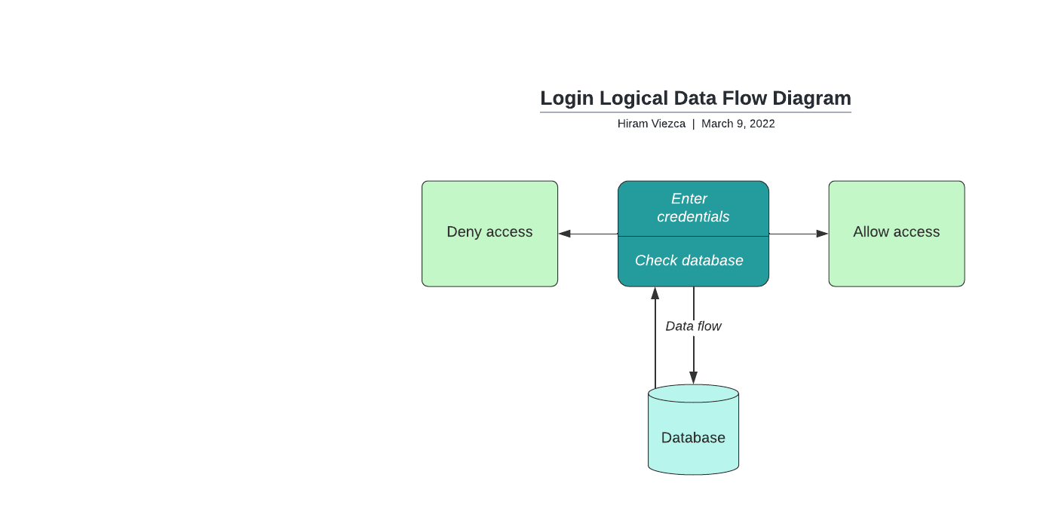

*Contact us*

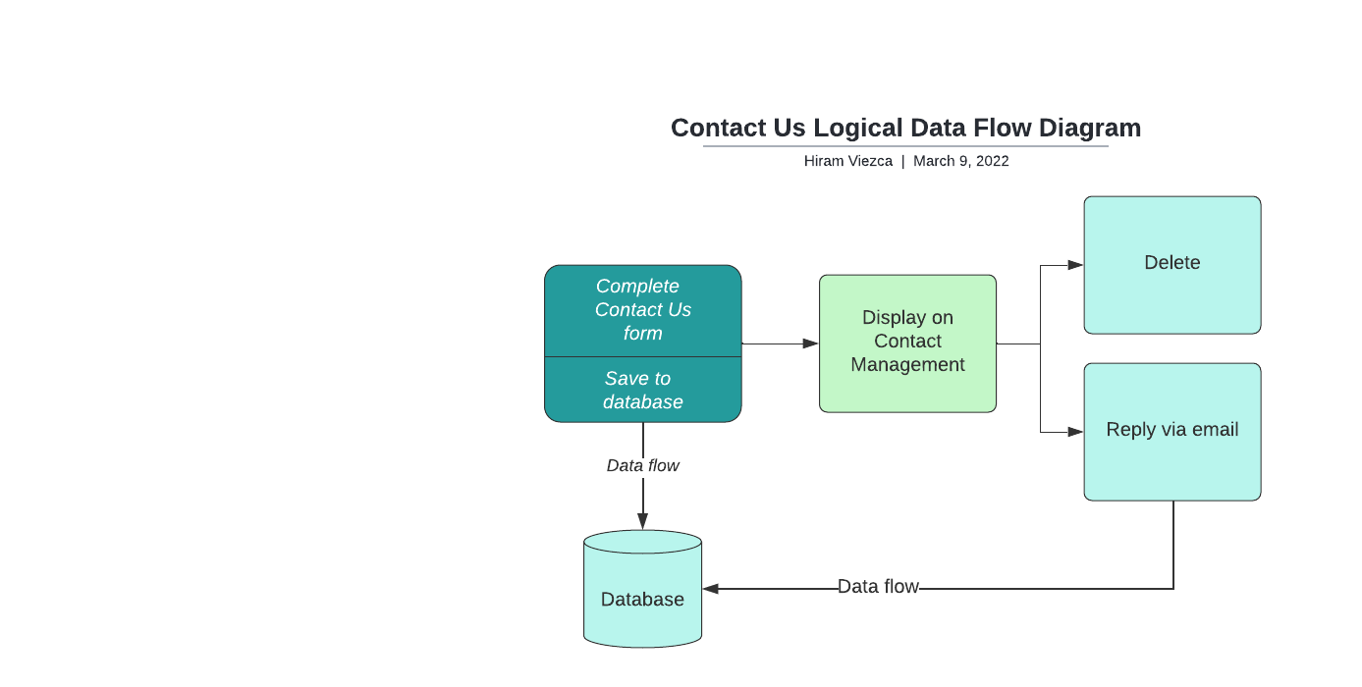

*Event Management*

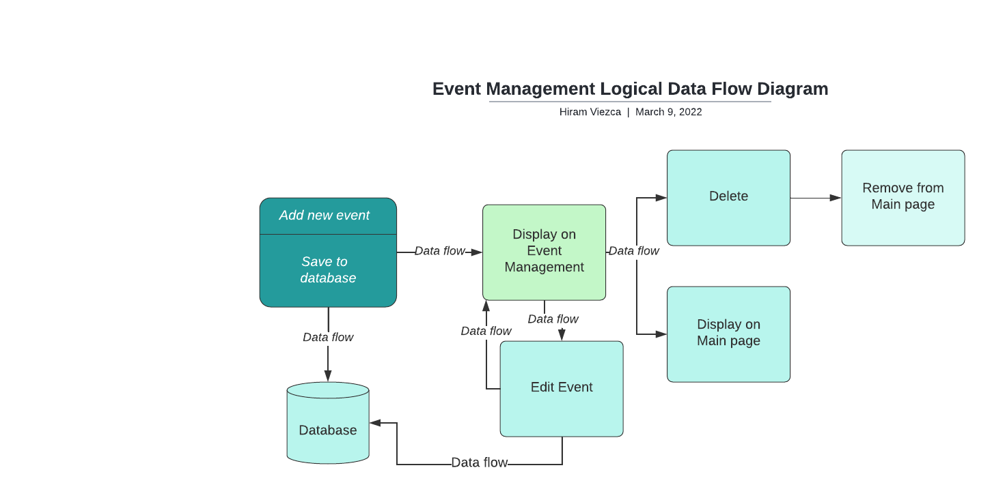

*Booking Management*

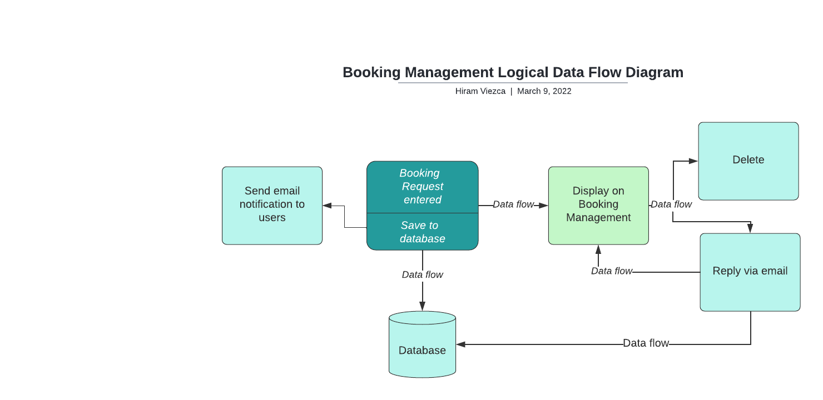

*User Management*

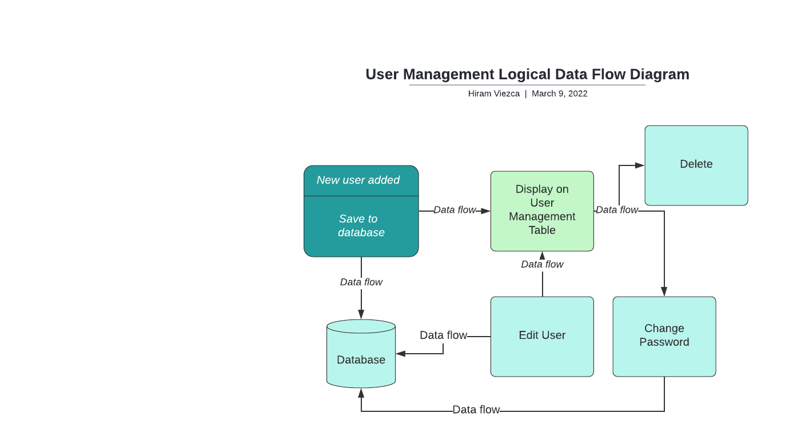

*Progress Management*

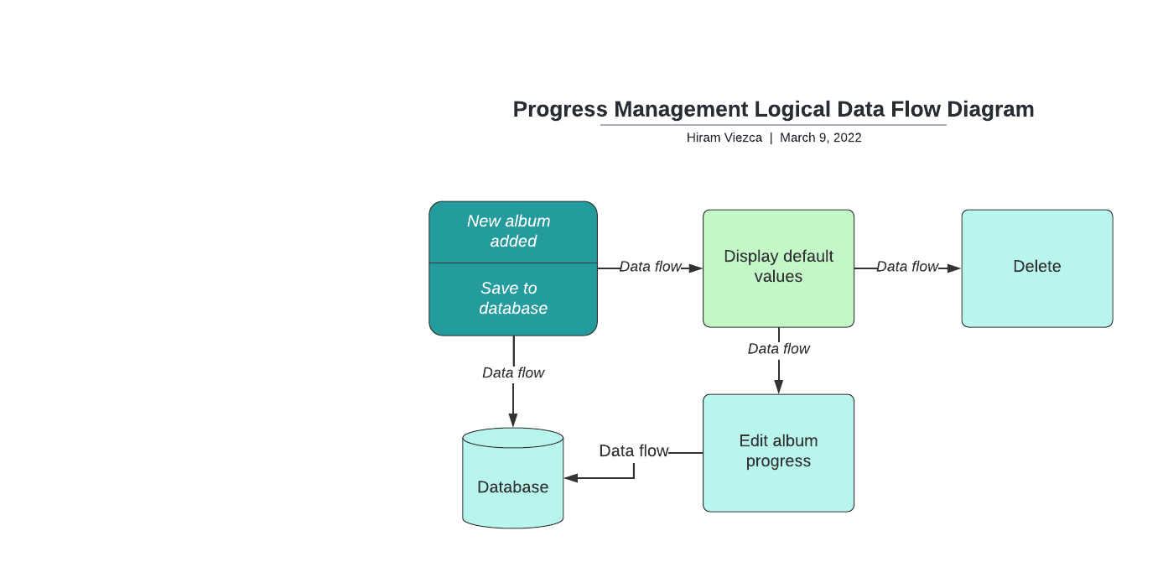

#### User Interface Design

Provide a sitemap and user interface design diagram for each user interface screen in the application, if not applicable, define the components of the project as described in the handbook.

*Site Map*

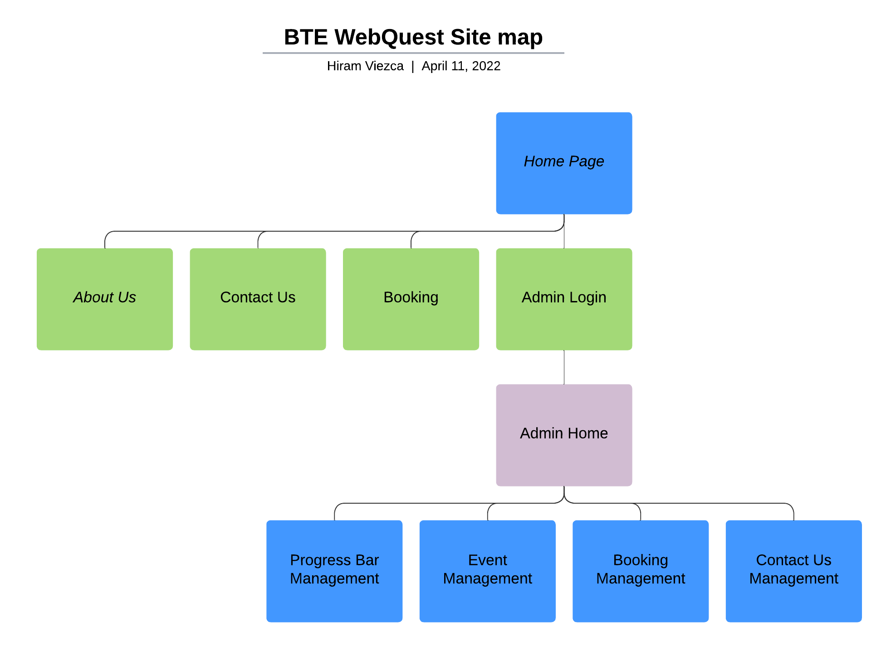

*Home Page*

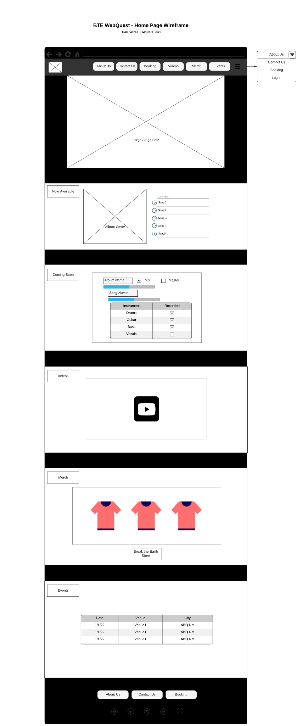

*About Us*

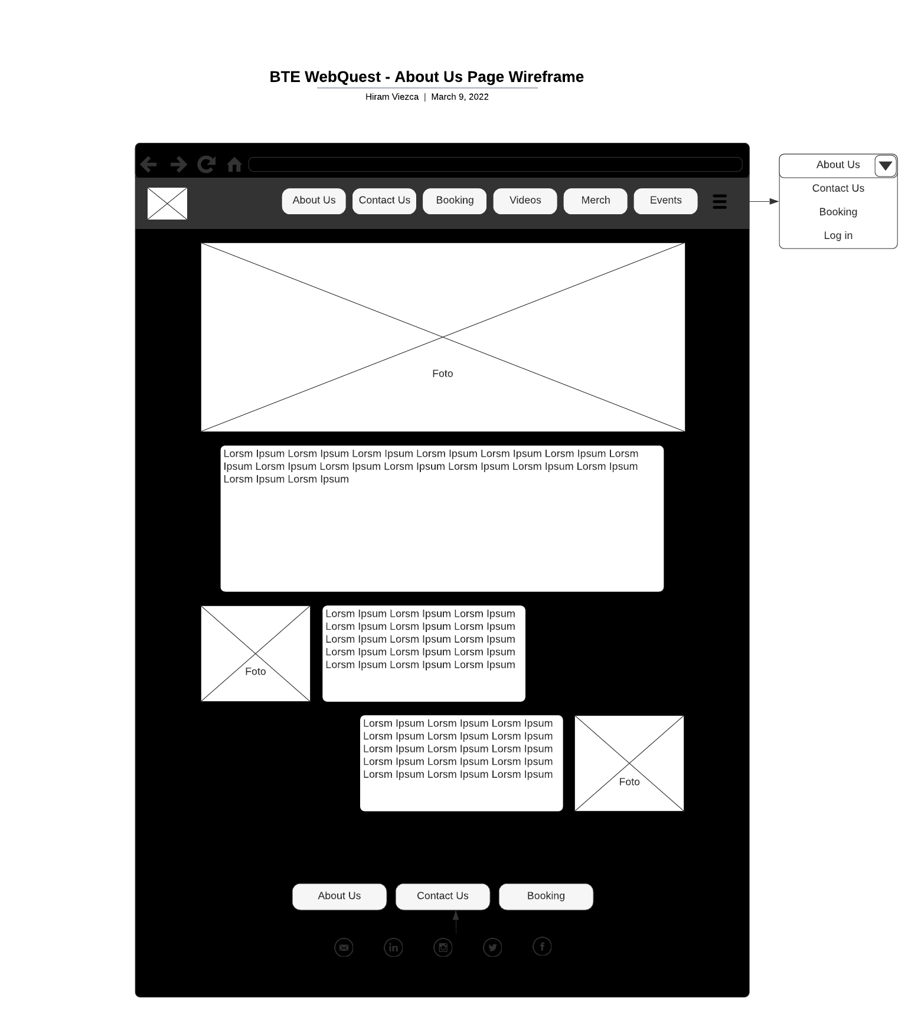

*Contact Us*

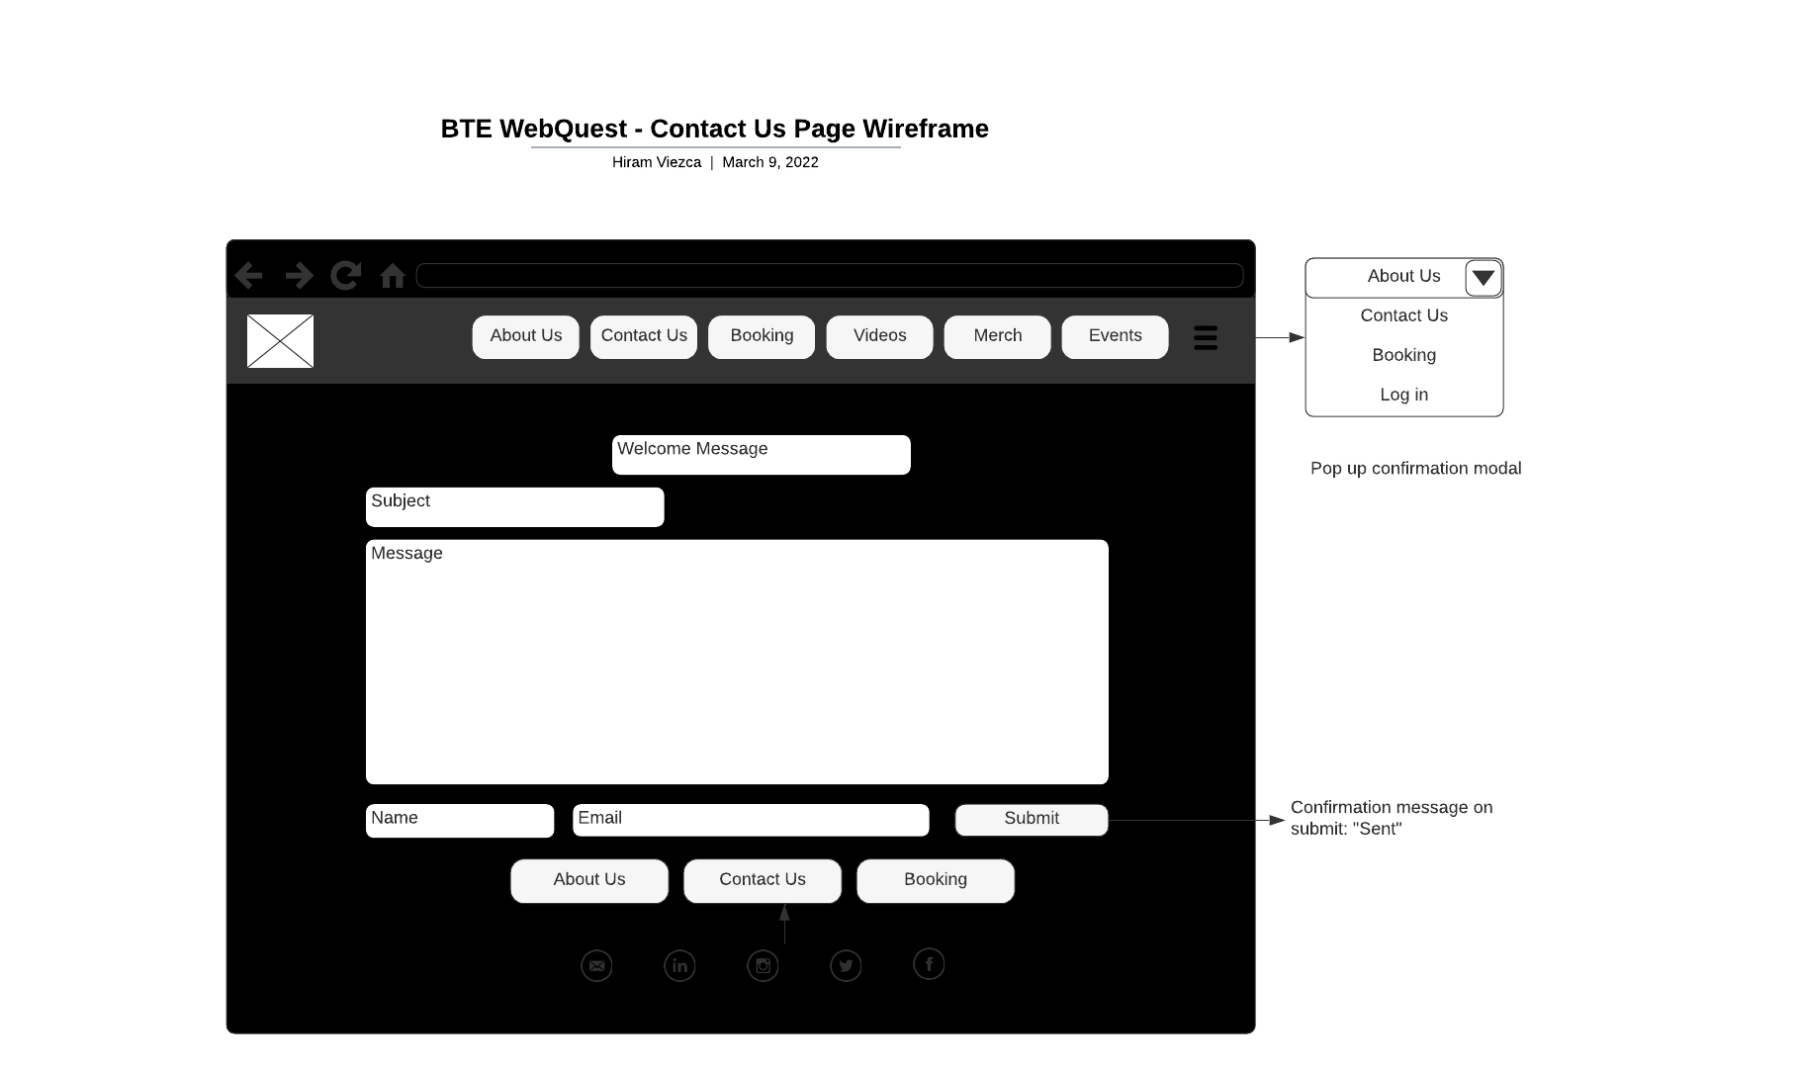

*Book Us*

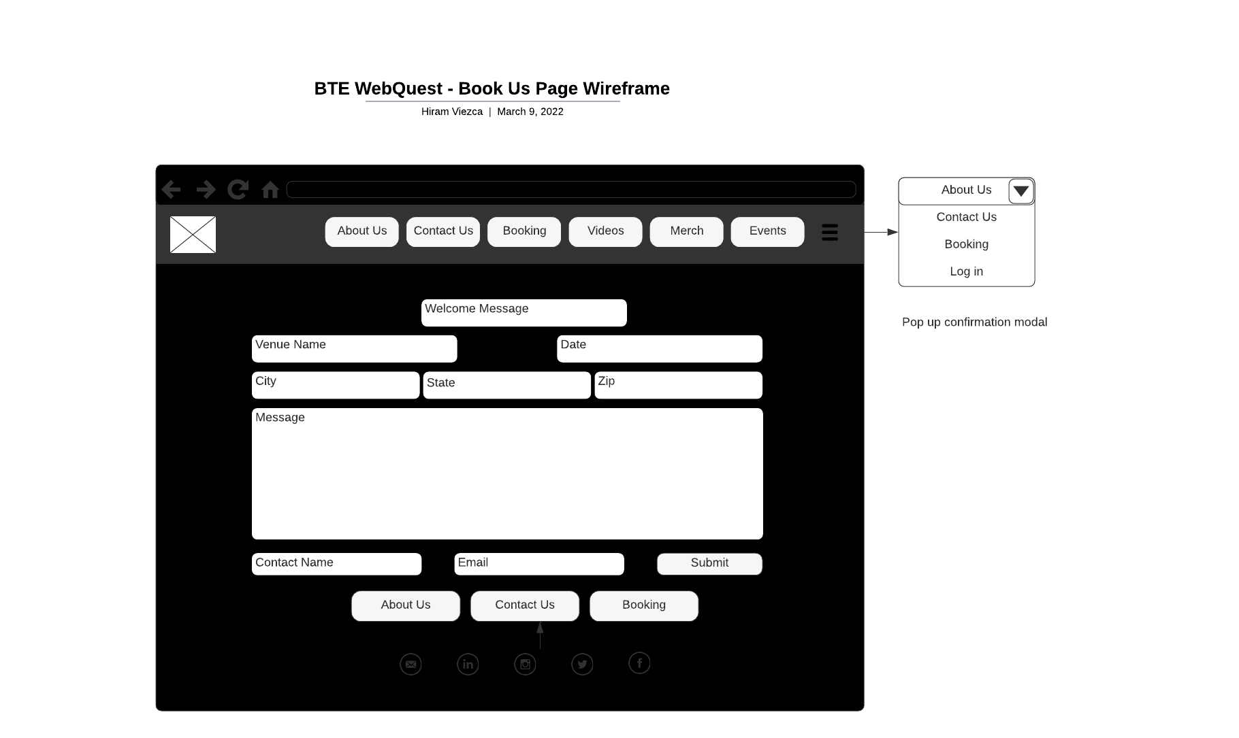

*Admin Login*

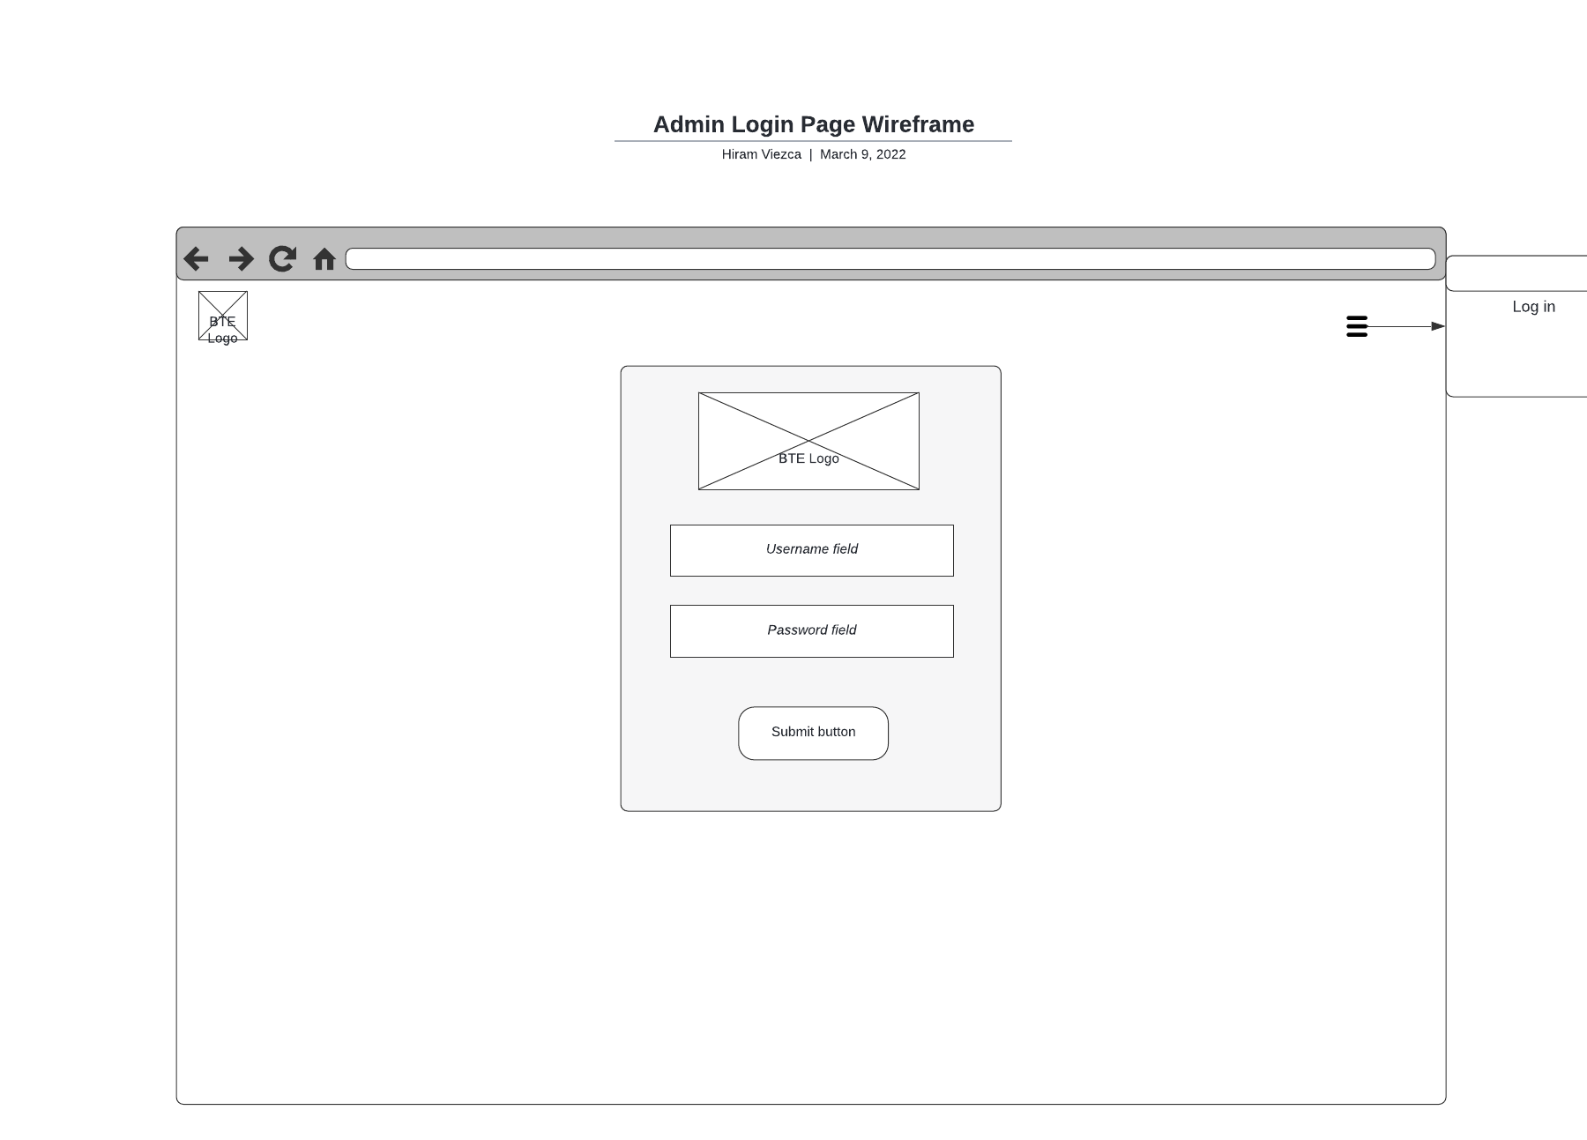

*Admin Home Page*

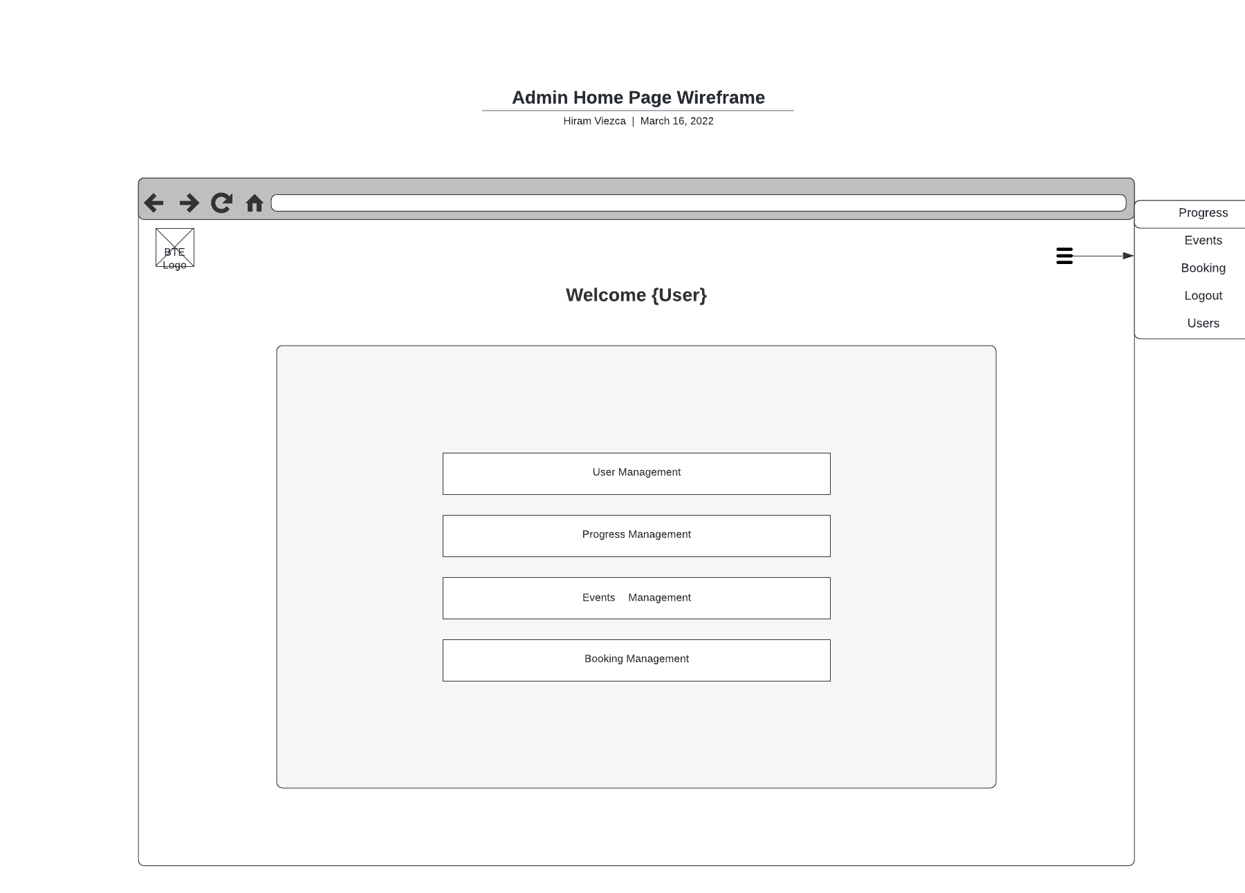

*User Management*

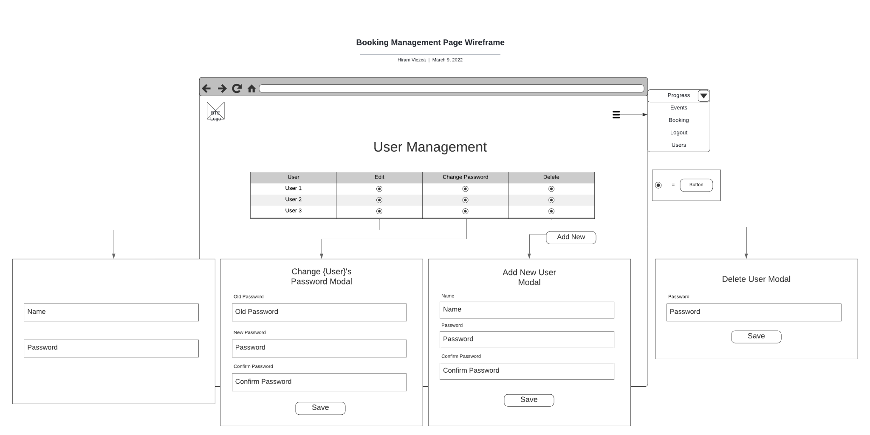

*Booking Management*

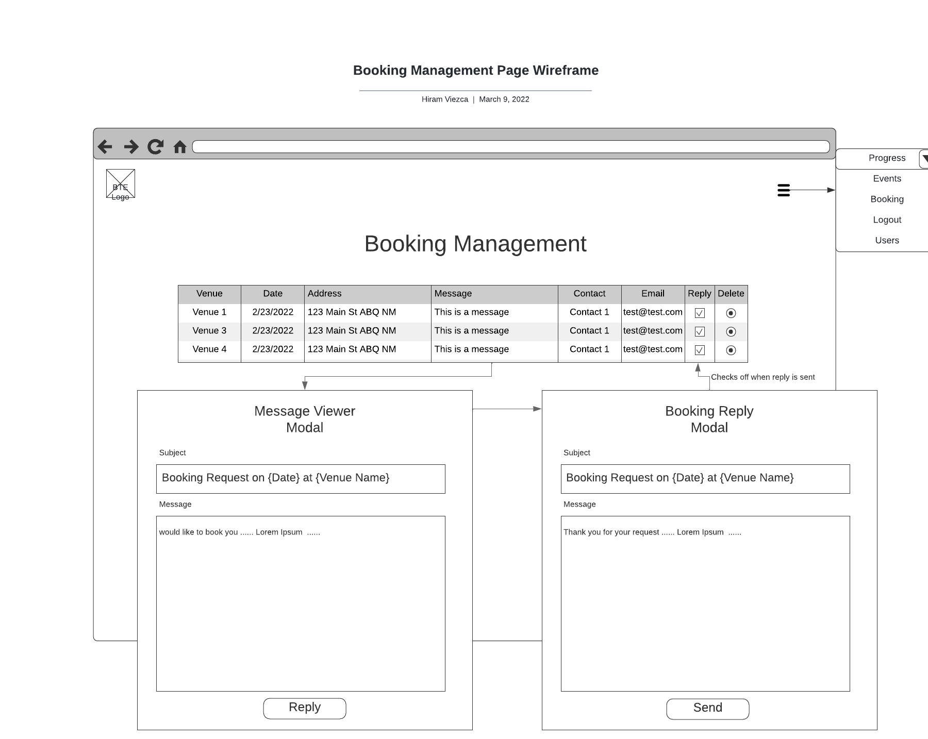

*Event Management*

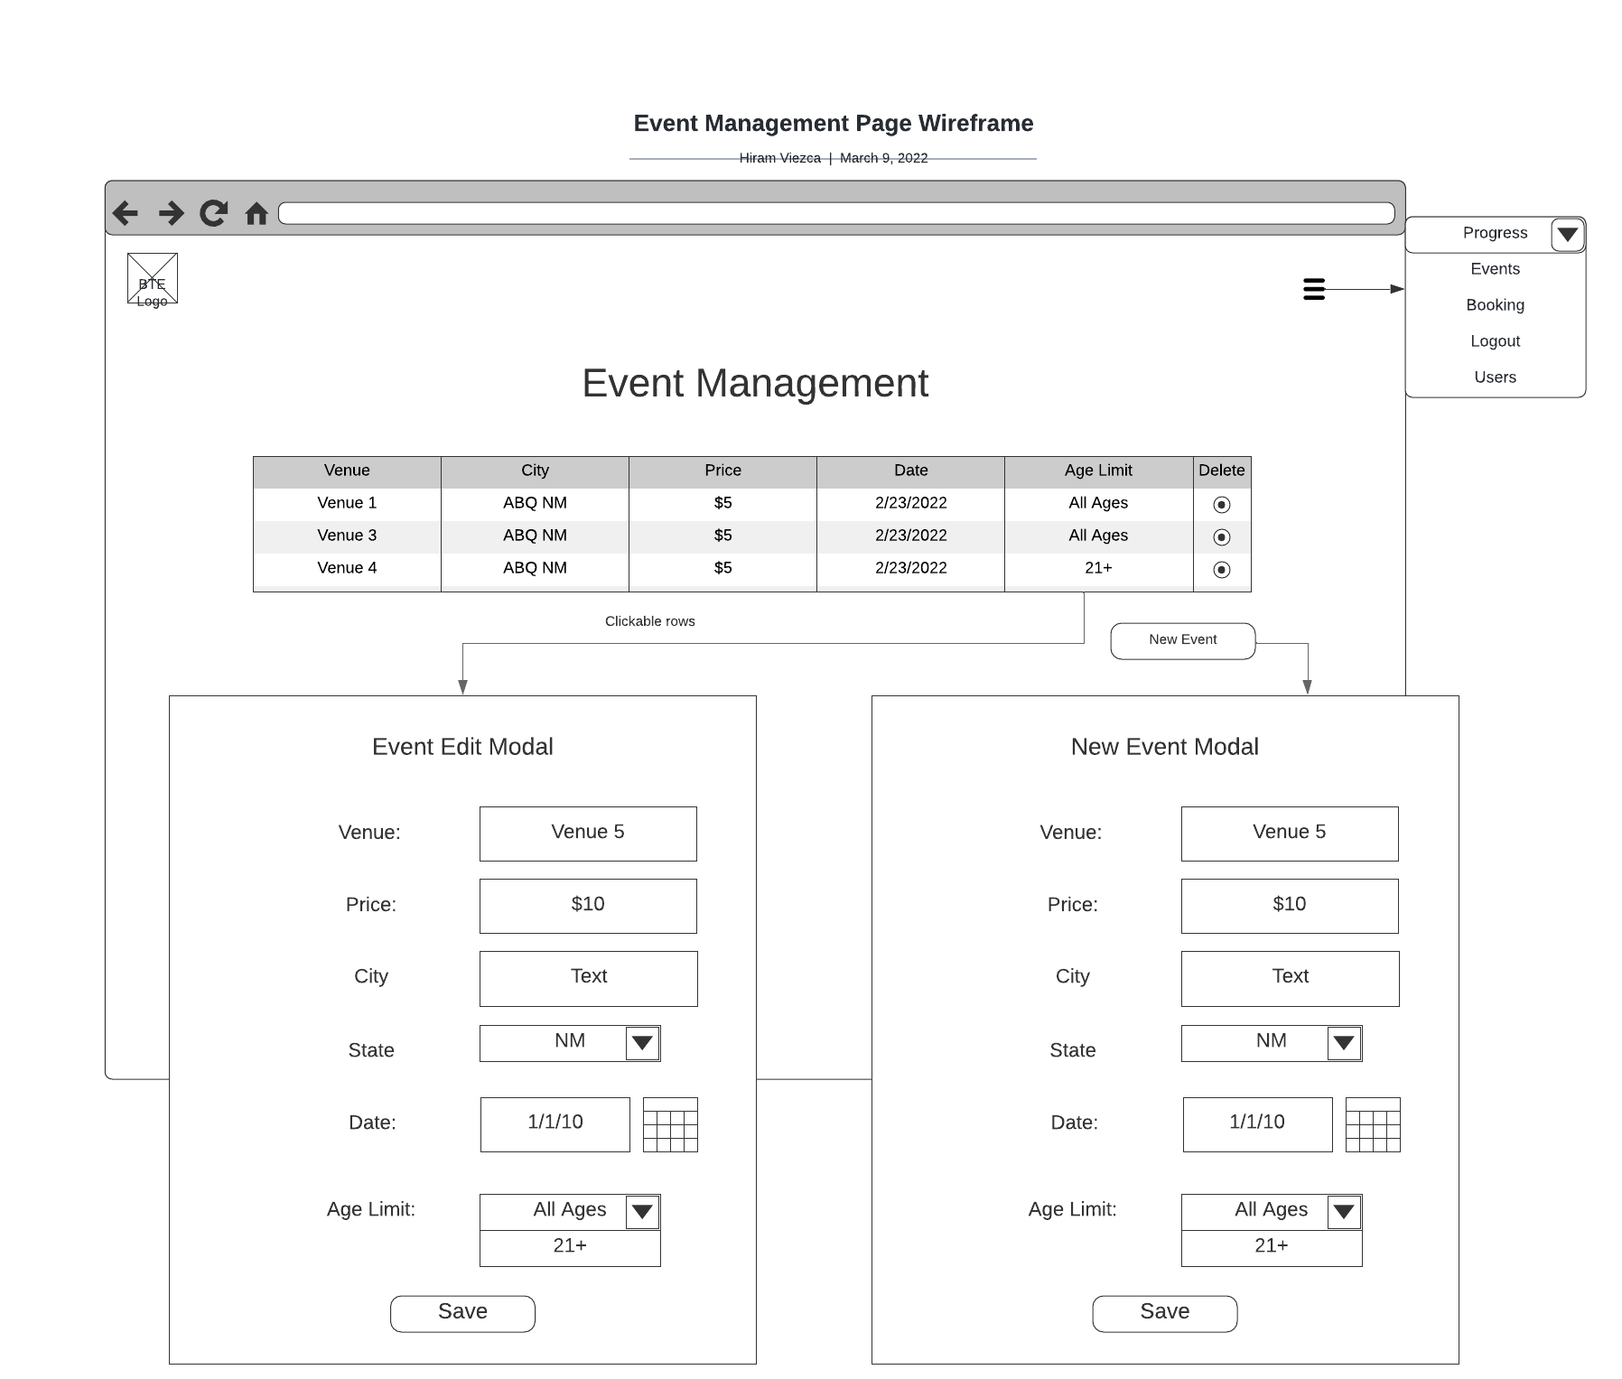

*Progress Management*

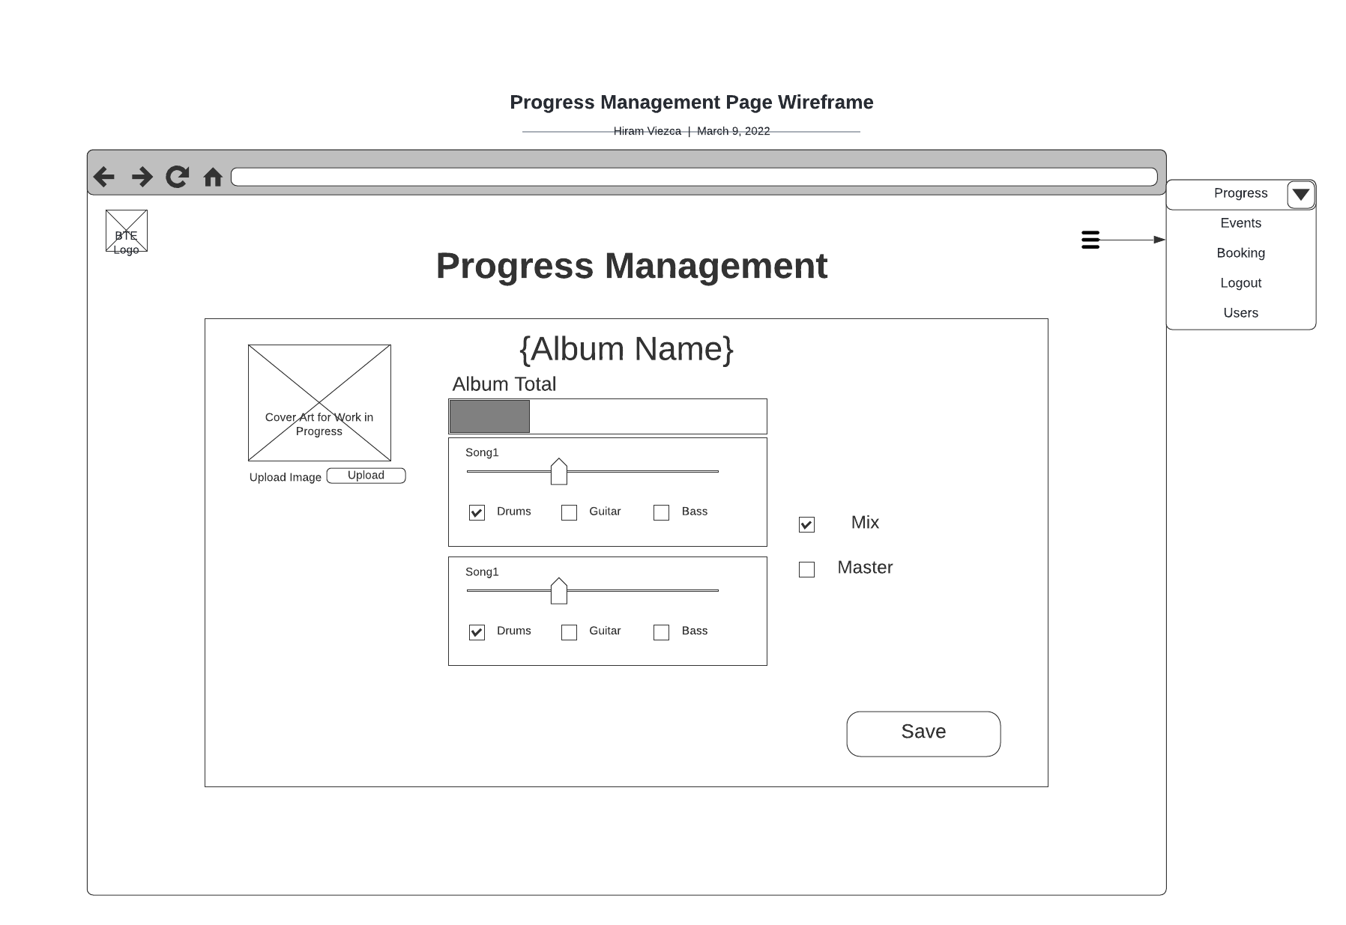

#### Reports Design

**Event Report**

The event report will provide a listing of all events between a selected timeframe. This report allows the band to review upcoming events for scheduling conflicts and past events to maintain a historical record. The report will include the event name, event date, event location, and any event notes. The information will be presented in a table format.

|  |  |  |  |
| --- | --- | --- | --- |
| **Report Title with From and to dates** | | | |
| **Event Date** | **Event Name** | **Event Location** | **Event Notes** |
| 3/7/2022 | Crazy Music Event! | Local Music Spot | All Ages with $10 cover. |
| 3/14/2022 | New Music Release | Online music places | Release of new Album! |

**User Logs**

The user log report will track the logging in and out of all users between a selected timeframe. This report allows the administrator to track all access to the web application. As only a handful of users have access, this will help ensure the site is kept secure. The report will include the username, time logged in, and time logged out of the web application. The information will be presented in a table format.

|  |  |  |
| --- | --- | --- |
| **Login date/time** | **Logout date/time** | **Username** |
| 3/7/2022 1500 | 3/7/2022 1530 | Administrator |
| 3/14/2022 0700 | 3/14/2022 0730 | BandDrummer |

#### Security

**Security**

Security for this web application will be accomplished through roles-based user access. General information pages are designed to provide information to all fans without registering and will be excluded from roles-based access. Access related to administrative tasks will fall under the “Admin” role and tasks pertaining to the upkeep of the site will be allocated to the “Editor” role. Roles based access will be implemented with Spring Security allowing roles to be assigned to a user.

The creation and removal of users will only be available to a user with the “Admin” role. A user with the “Editor” role will be able to update their own user information.

User passwords will be stored in the database as BCrypt hashes to protect this data in the case of a database breach.

|  |  |  |
| --- | --- | --- |
| **Security Matrix** | **Admin** | **Editor** |
| Create New User | X |  |
| Delete User | X |  |
| View Booking Requests |  | X |
| Update User Information |  | X |
| Update Event Schedule Section |  | X |
| Update Now Available Section |  | X |
| Update New Material Section |  | X |
| Update Video Section |  | X |
| View Event Reports |  | X |
| View Log Reports | X |  |